ASSIGNMENT 1
CUSTOMER TABLE

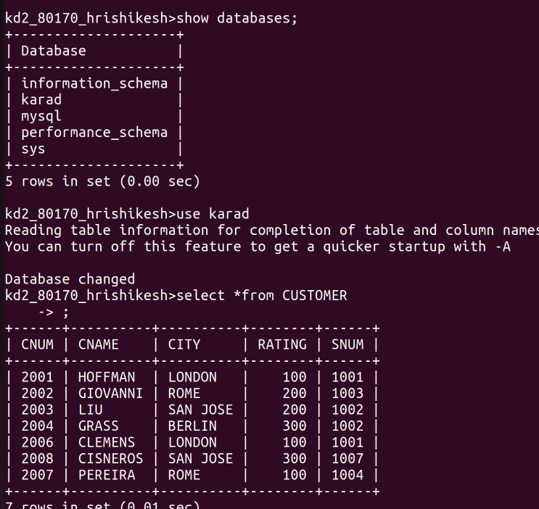
IMAGE OF CUSTOMER TABLE

SALES PEOPLE TABLE
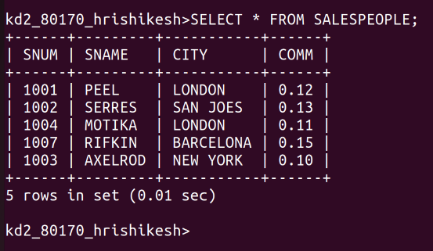
SALES PEOPLE TABLE

ORDER TABLE:
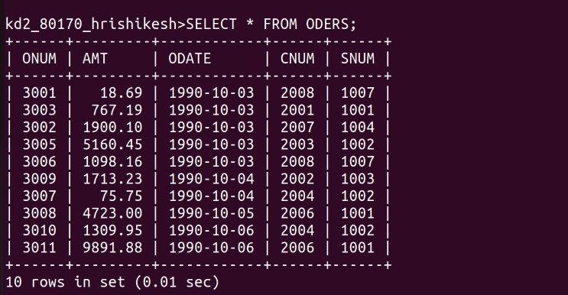
ORDER TABLE

ASSIGNMENT NO2

Q1 Which feild of the customer table is the primary key?
CNUM

Q2 what is the 4 th column of customer table ?
Rating

Q3 what is another word for row ? for column?
column call feild ,and row call as record or tuple

Q4 why is not it possible to see the first five row of table?
SQL tables represent unordered sets. So, there is no such thing as the first five rows or last row -- unless a column explicitly defines the ordering. Often, a table has some sort of auto-incremented id column, which can be used for this purpos

ASSIGNMENT NO 3

Q:1 Does ansi recognize the datatype DATE?
Ans:yes

Q2 which subdivision of sql is used to insert values in tables?
Aans:DDl
are the different components of SQL
DDL – Data Definition Language(create ,drop)
DQL – Data Query Language (select)
DML – Data Manipulation Language(update ,insert,delete)
DCL – Data Control Language
TCL – Transaction Control Language

ASSIGNMENT NO 4
Q1 ANS
Q2 ANS
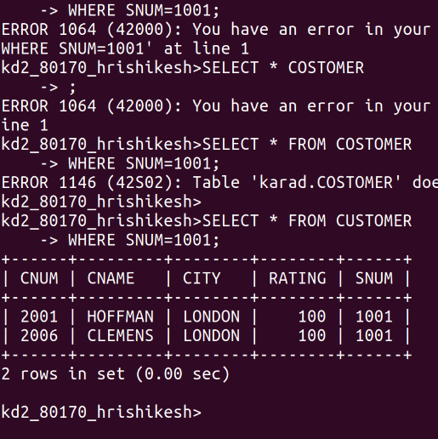

Q3 AND 4
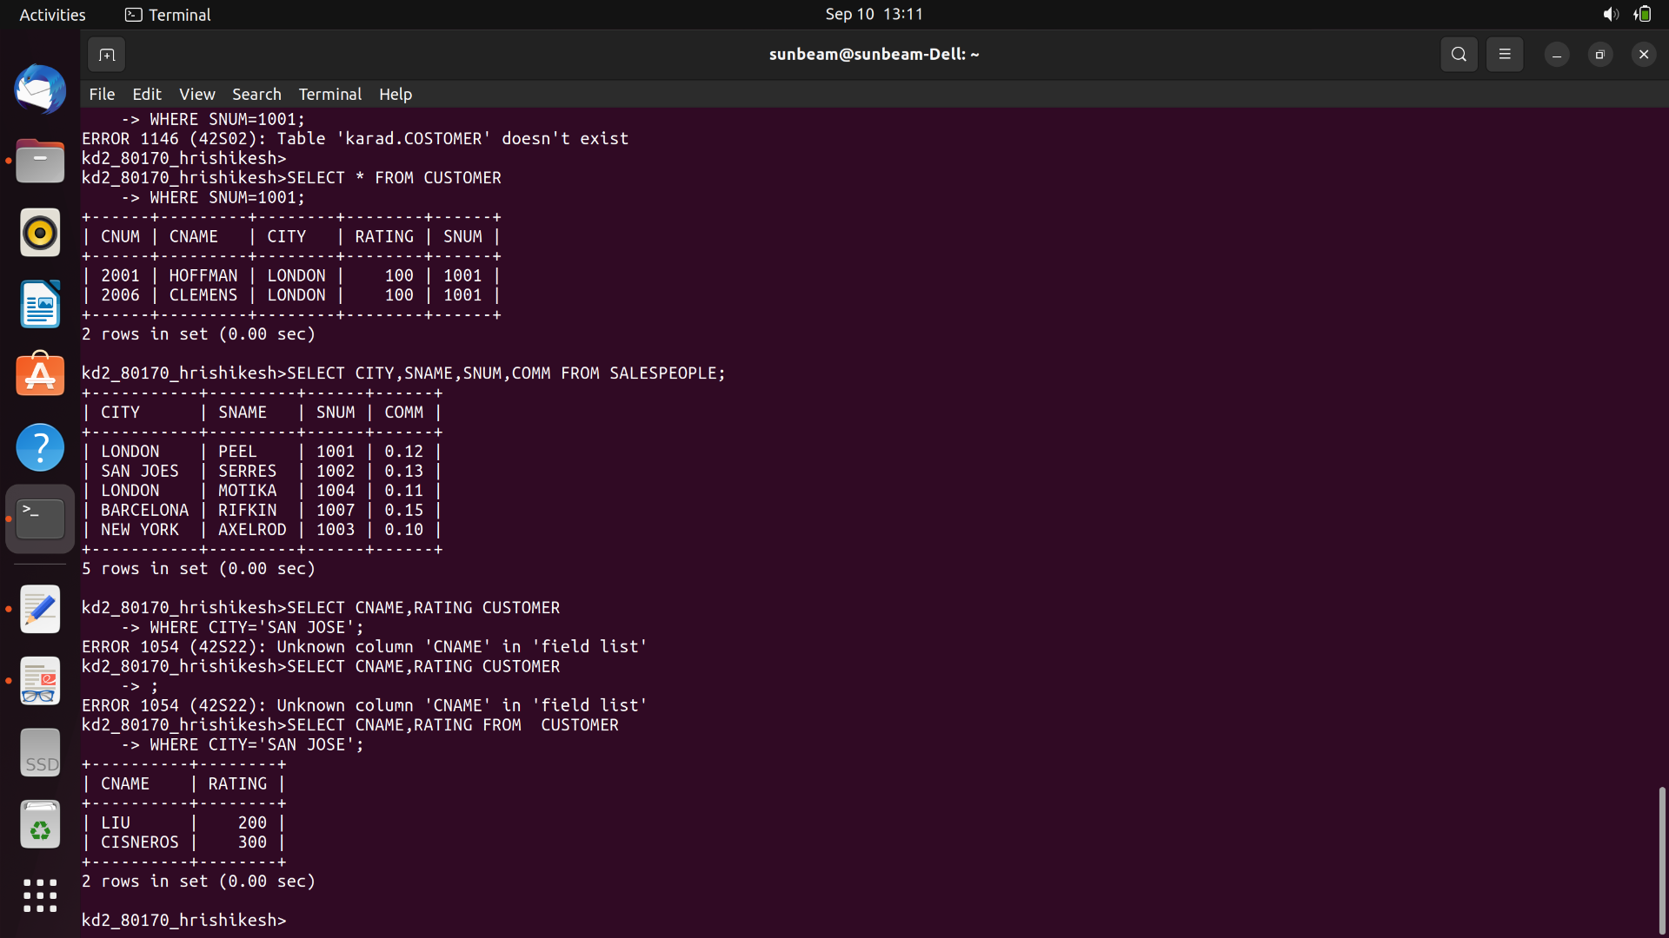

ASSIGNMENT NO 5
Q1
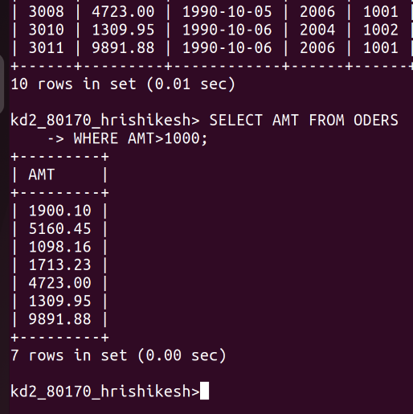
Q2
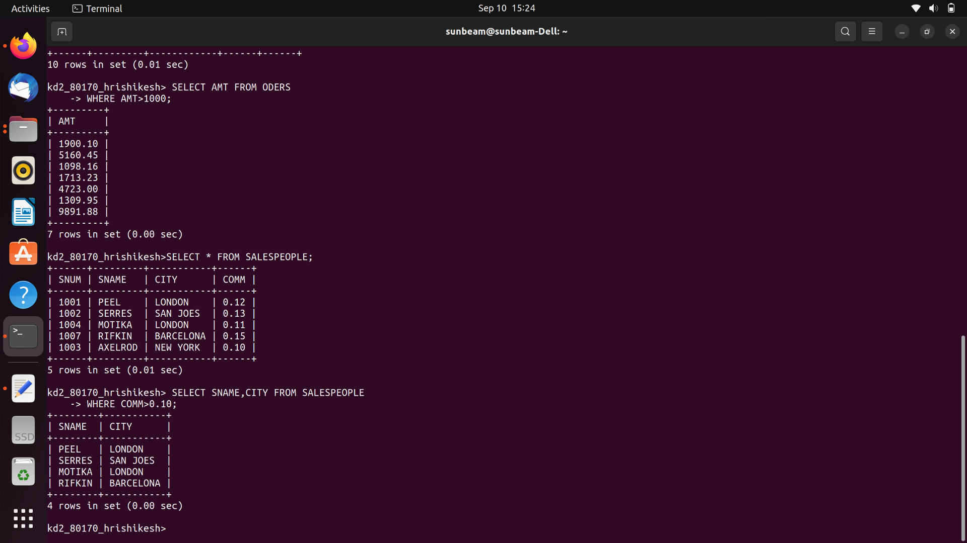

Q3
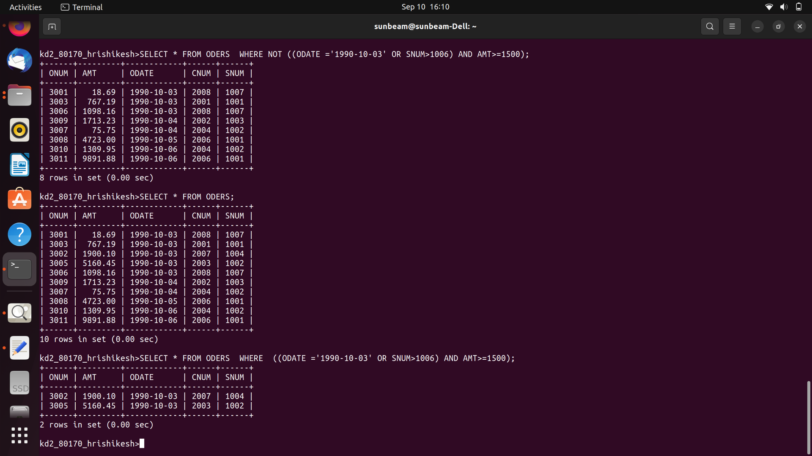

Q4

Q5
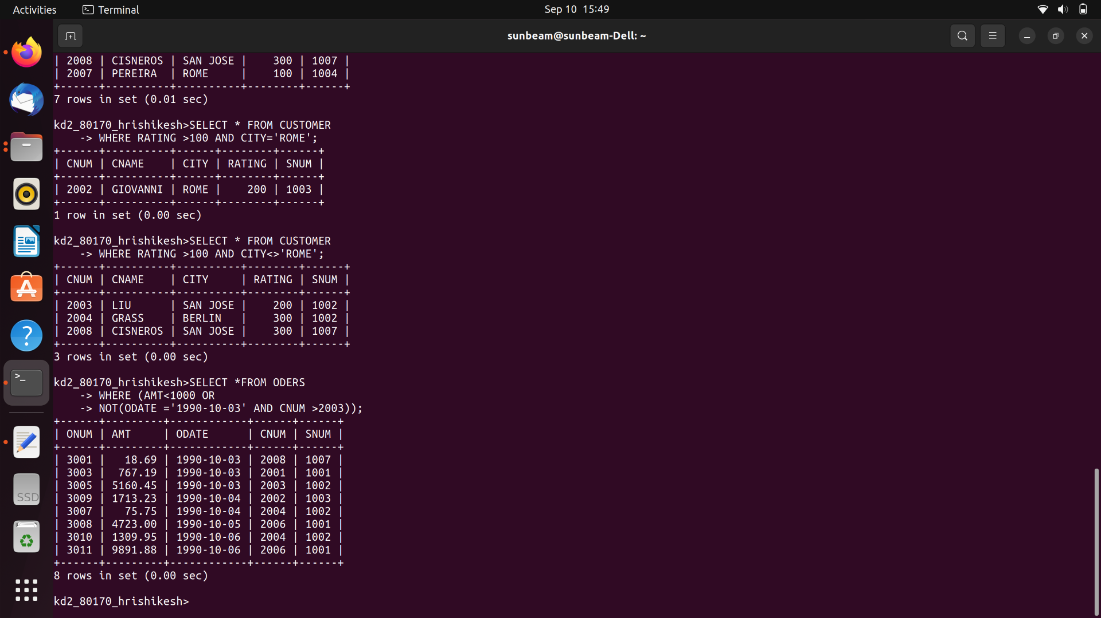

Q6
